Q1. Why repetitive -rw-r—r--?

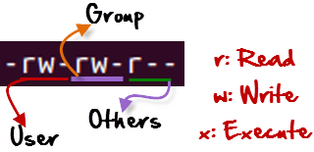

Q2. Why permission different?

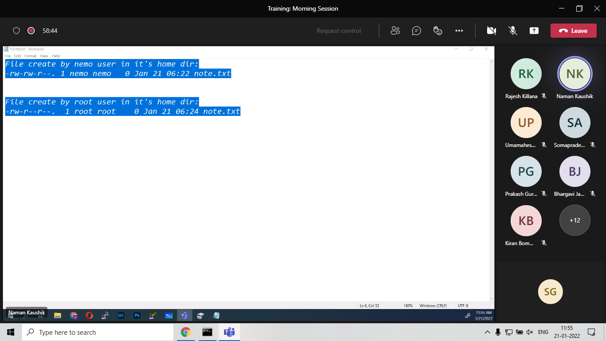

According to me this is due to default permission and user mask. Umask is the numerical value which is default permission for file and directory.

In screenshot user “Sid”(umask= 0002) and root(umask=0022) are having different umask in “/home” directory.

